Contact: Stephanie Abel-Hohenzy  Cedar Valley Hospice  Phone: (319) 272-2002  Fax: (319) 272-2071 | 2101 Kimball Ave., Suite 401  Waterloo, Iowa 50704-2880  www.cvhospice.org  shohenzy@cvhospice.org | 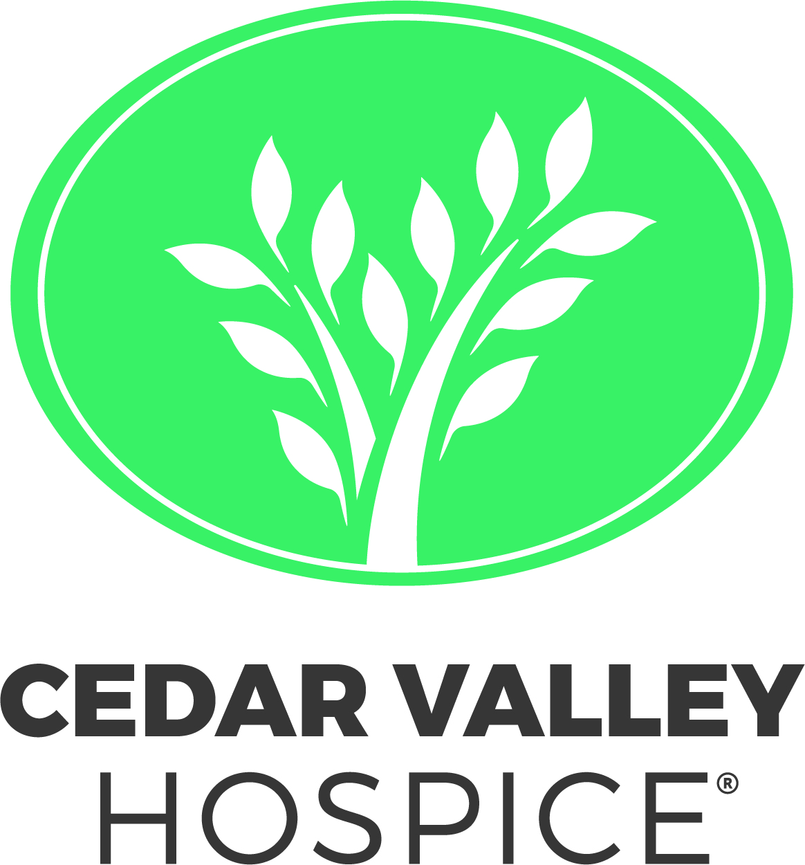

PRESS RELEASE

Waverly woman loses matriarchs, learns the value of hospice care

Waterloo, April 16, 2019: As Mother’s Day approaches, we are often reminded of important women that have made a difference in our lives. Amy Hamilton Kangas of Waverly is no different. She had close bonds with the women in her life, but also experienced several Mother’s Days without them.
Although losing her grandmother and her mother were difficult to experience, it is a consolation to her that Cedar Valley Hospice made a difference in the lives of both her greatest role models.
When Amy’s mother, Claudia Hamilton of Cedar Falls, was diagnosed with early onset Alzheimer’s Disease at 53, it was a shock for their family. Amy and her sister were in their 20s and their brother a junior in high school.
“It was very hard to come to grips with,” says Amy. “Mom was always the organizer, planner and cook so I worried about my dad and my siblings. I wondered what things my brother wouldn’t know/learn because my mom wasn’t able to tell him or teach him.”
Living an hour away at the time, she did her best to help and support her family but in 2004, Amy moved back because the disease was progressing. In 2005, her mom moved into a care facility where she could have around-the-clock care if she needed it.
Meanwhile, Amy’s grandmother, Lois, also had declining health. Because Amy’s mother was sick herself, she and her sister were Lois’ caregivers.
But when her grandmother needed more hands-on care, they had a discussion about getting help.
“I remember grandma not even hesitating,” said Amy. “She said, ‘Well, then we’re going to have Cedar Valley Hospice.’ She raved about how wonderful their care was when her nephew was at the Hospice Home. She knew that they took care of the entire family and she wanted to lessen the burden on us...and they did.”
Lois was adamant that she wanted to be served at her home. After she was admitted to the Cedar Valley Hospice program, she was assigned her own team of experts who would manage her care at her own residence and provide support for Amy and her sister. They all soon realized that hospice isn’t about dying but living life as fully as possible despite old age or a life-limiting illness.
“They provided everything she could have ever needed - medicine, baths, conversation, knowledge,” said Amy. “Plus, she didn’t need us there all the time, so we all could live a little too and have our own privacy.”
For months Cedar Valley Hospice cared for Lois “like one of their own,” Amy added. “And I knew that I could call anytime and that they would have the answers. Their respite care at the Hospice Home also enabled me to be able to go to work.”
When Lois’ health began to fail, Cedar Valley Hospice adjusted her care and monitored it - making for a smooth transition into her final stages. Lois died at home, peacefully and comfortably.
Years later, Amy found herself facing a similar situation, yet this time it was her mother. The Alzheimer’s disease had fully taken over her mother’s body, so much so that Amy had received a call to meet her dad, Duane, at the Emergency Room. Her mother had endured a couple seizures and had a serious infection. This time, it was Amy’s turn to not hesitate.
“We’re going to call Cedar Valley Hospice,” Amy said. “Dad wanted to believe that Mom would get better, but she wasn't responding to the antibiotics, and she hadn't been fully able to communicate since 2007. So many years ago, I had cried and argued with God. At that point, I just wanted her to be comfortable.”
The doctor agreed with their decision and on Dec. 22, 2015, Cedar Valley Hospice welcomed her into their Hospice Home.
“For us, it was a place where we could all be together and people could come see my mom and dad,” said Amy, who remembers the experience fondly. Trees were decorated in every room, Christmas cookies overflowed and they often enjoyed family dinners in the kitchen/ family room area. “It was a place that felt like home,” she said smiling.
Amy also appreciated that during the holiday, they could still manage their routine and not have to worry.
“I could come home at night and sleep knowing everyone was being taken care of,” she said. “Their staff was so attentive to our needs - all the way up until the end. The last night they even made it possible for my dad to lay down with my mom until she passed. It was very special.”
Although Amy has lost two matriarchs of her family, she is so grateful to have had Cedar Valley Hospice by her family’s side. She realized that hospice care enables moments and memories that would otherwise not occur. It is the quality of these final moments, after all, that most would define as a good death.
Cedar Valley Hospice offers hospice care and palliative care programs that help those facing a life-limiting illness at various stages. It’s never too soon to call 319.272.2002 or visit cvhospice.org and find out how our experts can help.
###
PHOTOS (2)
Amy and husband: Amy Kangas and husband, Tim, are both grateful that Cedar Valley Hospice exists to help make life easier for families when their loved ones are ill.
Around the table: Amy snapped this photo before her grandmother, Lois Jensen and her mother, Claudia Hamilton, became very sick. It was a memorable day with the two of them and Amy’s father, Duane.

_____________________________________________________________________________________________________
Established in 1979, Cedar Valley Hospice is the expert provider of hospice care in Northeast Iowa. As a non-profit, we uphold the highest standards for our employees who help families manage advanced illnesses and symptoms 24 hours a day. We provide care for all – regardless of age, diagnosis or ability to pay. Other services include: the area’s only Hospice Home, palliative care, adult and children’s grief programs, and case management for those with HIV or AIDS. Anyone can make a referral. It’s never too early to call and find out what resources are available to you. For more information, visit cvhospice.org or call 800.626.2360.

